**Group2 Project Report (Maxwell House Ground Coffee)**

# Introduction

The report lays out the analysis performed on the scanner data and panel data focusing on the brand of Maxwell House ground coffee. All the analysis results are focused on Maxwell House ground coffee.

# Descriptive Analysis

The top 6 brands by dollar sales (dollars/units) are:

Our brand is competing closely with Starbucks in terms of dollar sales (calculated by Dollar Sales = Dollars/Units). The market share looks almost equal for Starbucks and Maxwell house. Let us check if that is the case by carrying out t-test between mean dollar sales of Starbucks and Maxwell House. The parent company of both brands is KRAFT FOODS INC.

# T-test of mean dollar sales between Maxwell House and Starbucks

**Null hypothesis:** Mean sales of Maxwell house = Mean sales of Starbucks

**Alternate hypothesis:** Mean sales of Maxwell house != Mean sales of Starbucks

From the t-test, we reject null hypothesis in favor of alternate hypothesis and conclude that the mean dollar sales of Maxwell house is significantly different from mean dollar sales of Starbucks. In fact, the mean sales of Maxwell house in less than that of Starbucks.

# Top 5 brands within KRAFT FOODS INC.

# Top 5 brands within KRAFT FOODS INC. in Ground Coffee Category

Overall, Starbucks leads by dollar sales, but in Ground coffee category, Maxwell House leads by Dollar sales.

# Top 5 regions where sales of our brand is highest

# Top 5 stores where sales of our brand is highest

# Visualization of number of units sold per week for Maxwell house Ground Coffee

# Weekly price per ounce of Maxwell House Ground Coffee

# Correlation between Units sold and average price per ounce

There is a negative correlation (-70.83) between Units sold and average price per ounce.

As expected, the number of units sold is higher when average price per ounce is lower.

# ANOVA to test of categorical features such as Flavor, Packaging and Brewing method affect dollar sales

## Flavor

Null hypothesis: Dollar sales of all flavors is equal

Alternate hypothesis: Dollar sales of all flavors is not equal

From ANOVA, we observe that dollar sales of Regular flavor coffee is significantly different from other flavors

## Packaging

Null hypothesis: Dollar sales of all type of packaging is equal

Alternate hypothesis: Dollar sales of all type of packaging is not equal

From ANOVA, we observe that dollar sales of Canned packaging in significantly different from other flavors.

## Brewing Method

Null hypothesis: Dollar sales of all type of brewed coffee is equal

Alternate hypothesis: Dollar sales of all type of brewed coffee is not equal

From ANOVA, we conclude that dollar sales of all-purpose coffee is higher than other brewing methods.

# SUMMARY OF DECRIPTIVE STATISTICS AND NEXT STEPS

From the descriptive statistics above, we know that Maxwell House is the leading brand in the ground coffee category. The main objective is to retain the leading position by retaining the existing customers. To carry out the loyalty campaign, we need to identify the customers who are loyal to our brand and add brings higher monetary values.

We can identify the customers by using RFM and Clustering.

# RFM and Cluster Analysis

The panel data is used in conjunction with IRI week translation data to calculate Recency, Frequency and Monetary* (RFM) values and perform Cluster Analysis to identify customers which add to monetary value of the brand. Once the RFM values are calculated, we normalize the data and determine the number of clusters.

*Monetary value is calculated as (Dollars/Units)

The number of clusters the customers to be segmented can be identified by the elbow curve below:

After 5 clusters, we do not obtain a significant gain. So, we can segment the customers into 5 segments.

## K-Means Clustering

We will be applying k-means clustering technique to segment the customers by RFM values.

The clusters obtained from k-means clustering are:

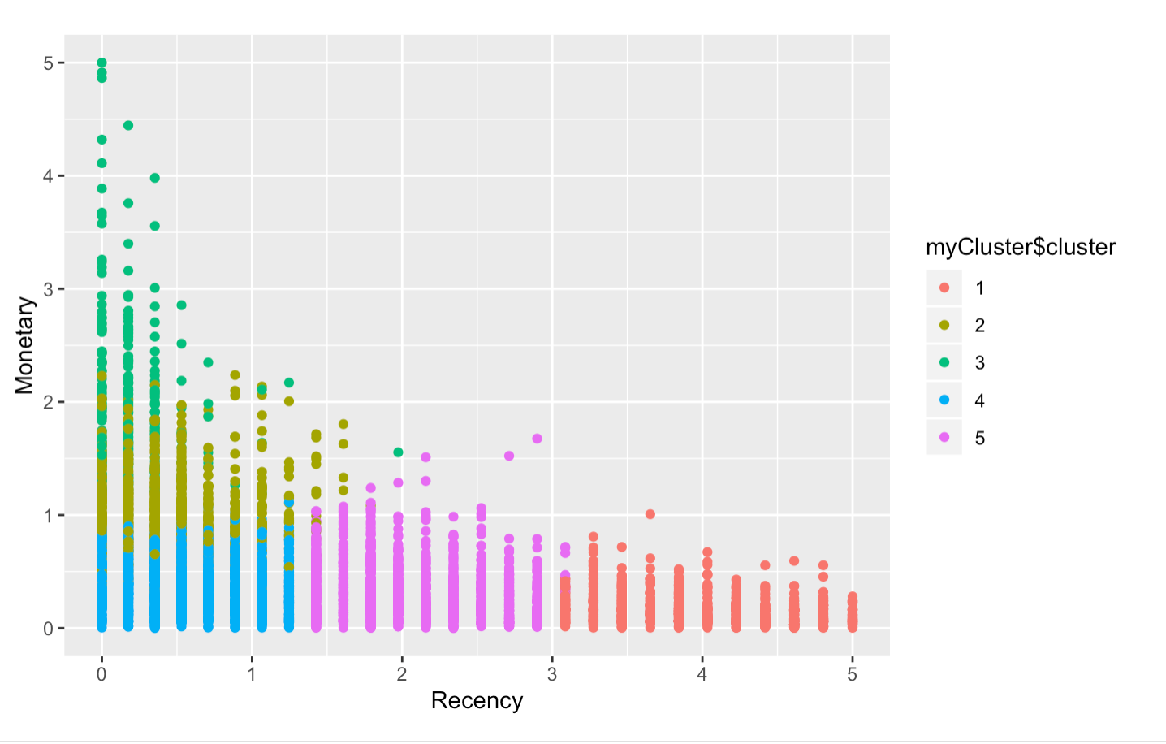

After segmenting the customers into 5 clusters, we observe the following:

* The customers in the **cluster 3** are most loyal and generate highest monetary value.
* The customers in **cluster 2** are the next segment who are loyal and generate good monetary value.
* The customers in **cluster 4** have are loyal but does not generate great monetary value.
* The customers in **cluster 1** and **cluster 5** are less frequent buyers and does not generate as much monetary value as cluster 3.

## Marketing/Managerial Recommendation

* Start marketing campaign for **loyalty program targeting customers in Cluster 3 and 2** as they are most likely to respond to the offer.
* We can start **bundling offers such as Buy 2 and Get 1** offers for customers in Cluster 4 as they are loyal, and bundling may result in customers from Cluster 4 generating higher monetary value.
* We can save on marketing by **not targeting** the customers in cluster 1 and 5 as they are not likely to respond to marketing campaigns.